Practical - 2
Practical Title: Semantic HTML5 Pages with Accessibility-Ready Structure

Problem Definition: Develop static HTML5 skeletons for at least 10 StudentHub pages such as Home, About, Register, Login, Dashboard, Events, Profile, Contact, Admin, FAQ, and Feedback. Use semantic tags and accessibility-friendly structure.

Theory

1.Are semantic tags such as header, nav, main, section, article, aside, and footer used properly?
Answer: Yes, semantic tags such as <header>, <nav>, <main>, <section>, <article>, <aside>, and <footer> are used properly. They make the HTML structure clear, improve readability, help search engines understand the webpage, and make the website more accessible and easier to maintain.

2.Are form labels, headings, image alt text, and navigation links accessible?
Answer: Yes, form labels, headings, image alt text, and navigation links are made accessible. Proper labels help users understand form fields, headings provide a clear page structure, alt text describes images for visually impaired users, and navigation links allow users to move easily between pages. This improves the usability and accessibility of the website.

3. Is the page structure consistent across all pages?
Answer: Yes, the page structure is consistent across all pages. Common elements like the header, navigation menu, main content area, and footer are maintained throughout the website. This provides a uniform design, improves user experience, and makes navigation easier for users.
Evidence of Work (Screenshots)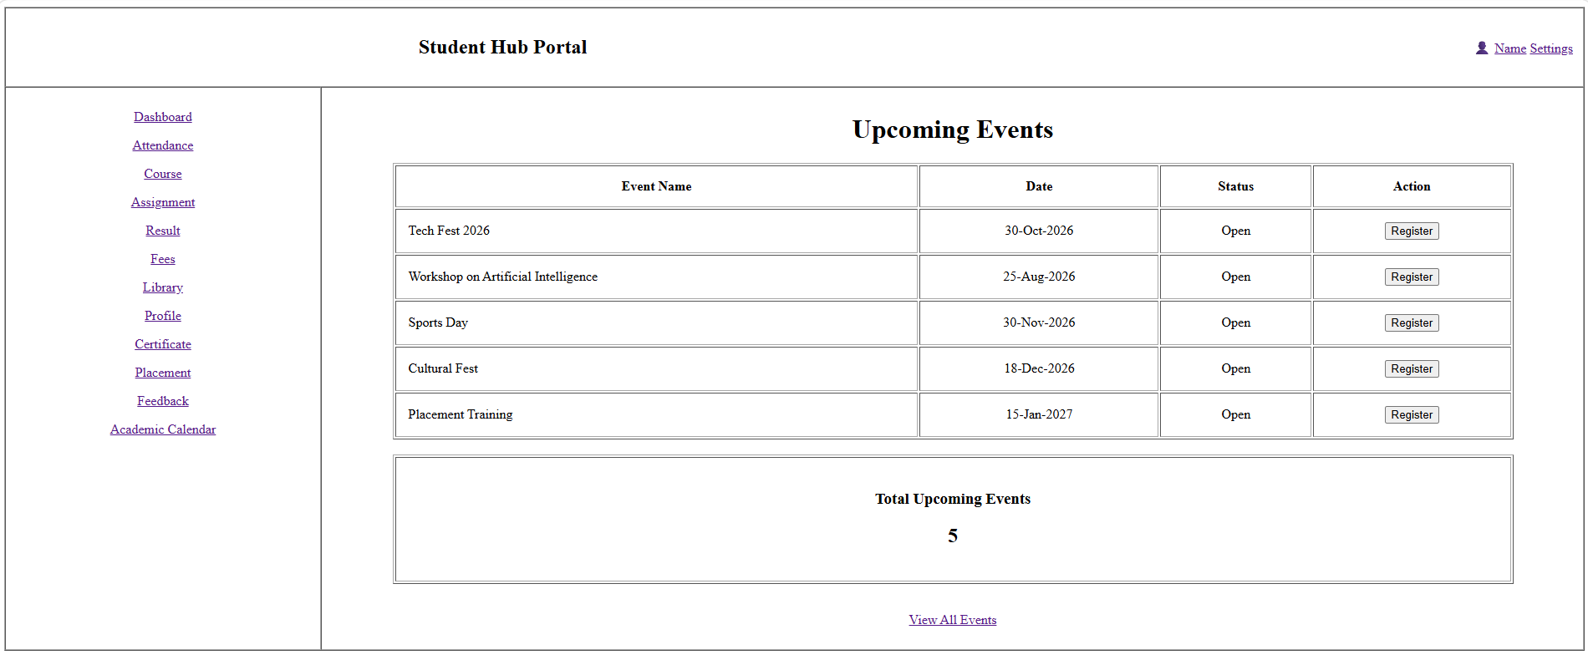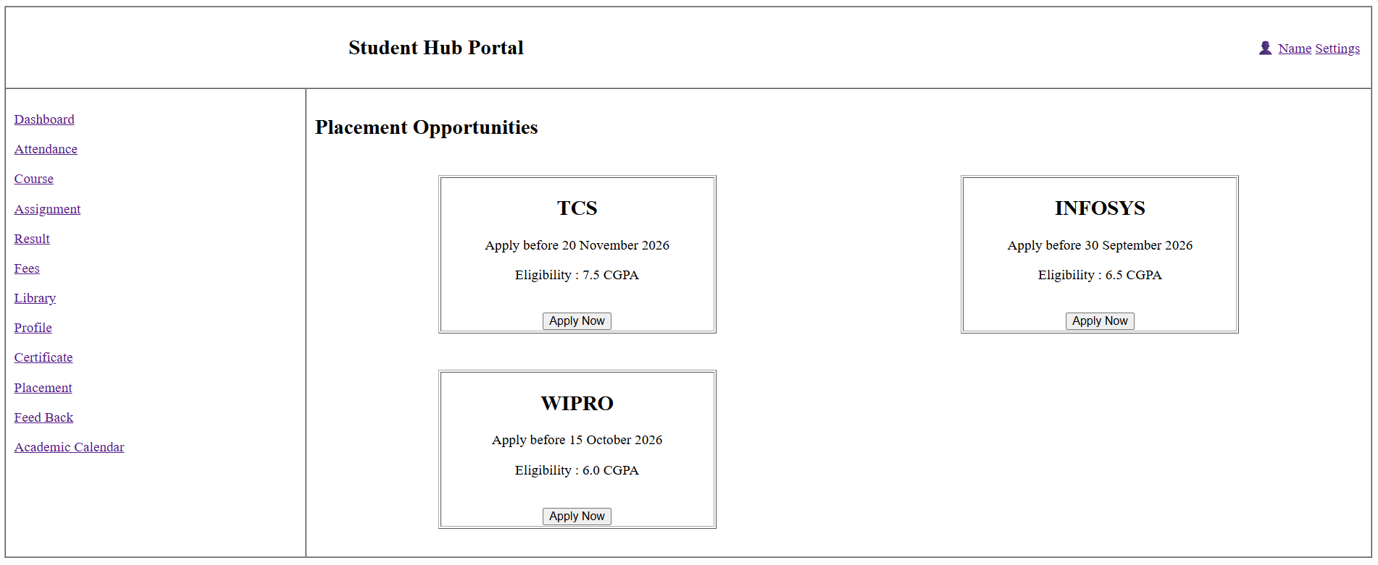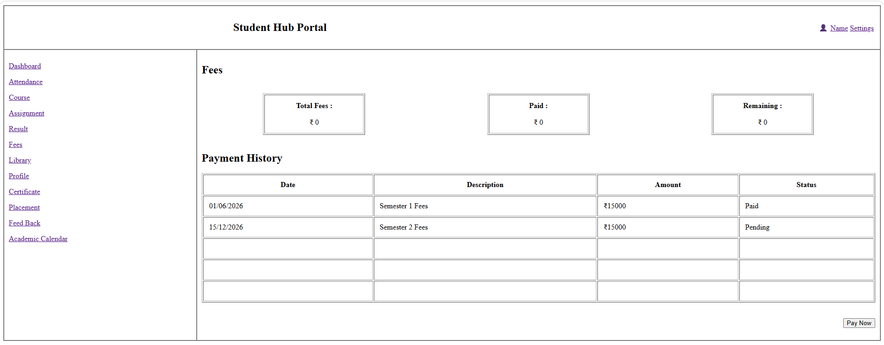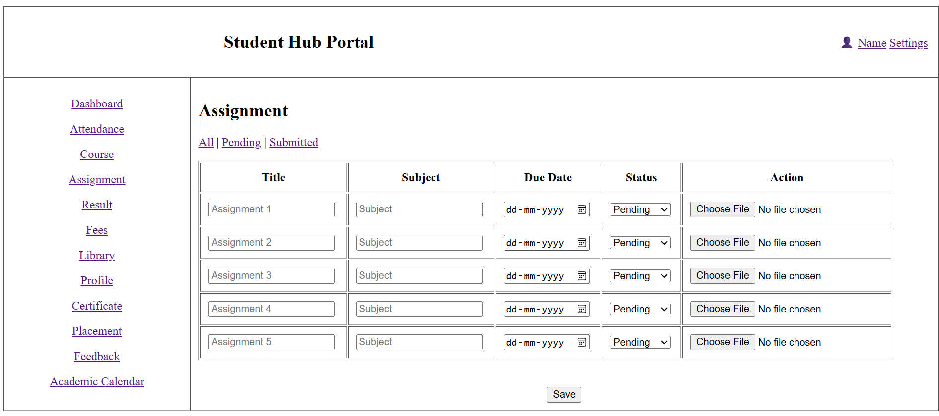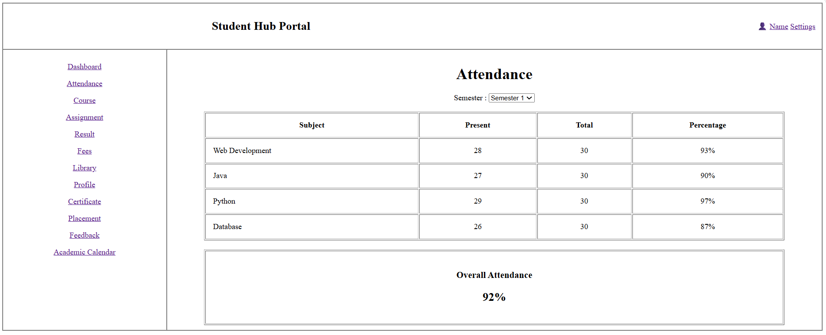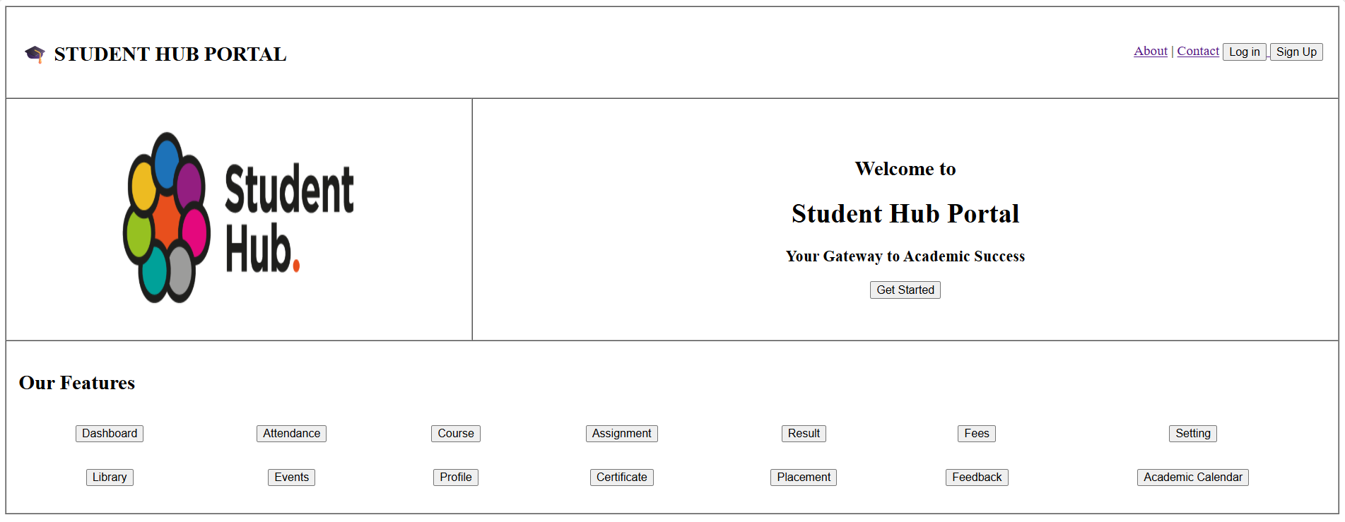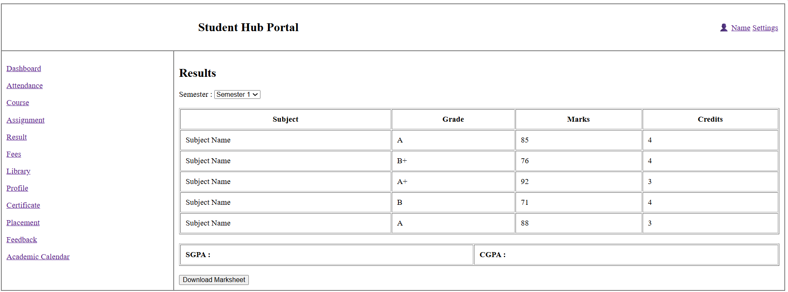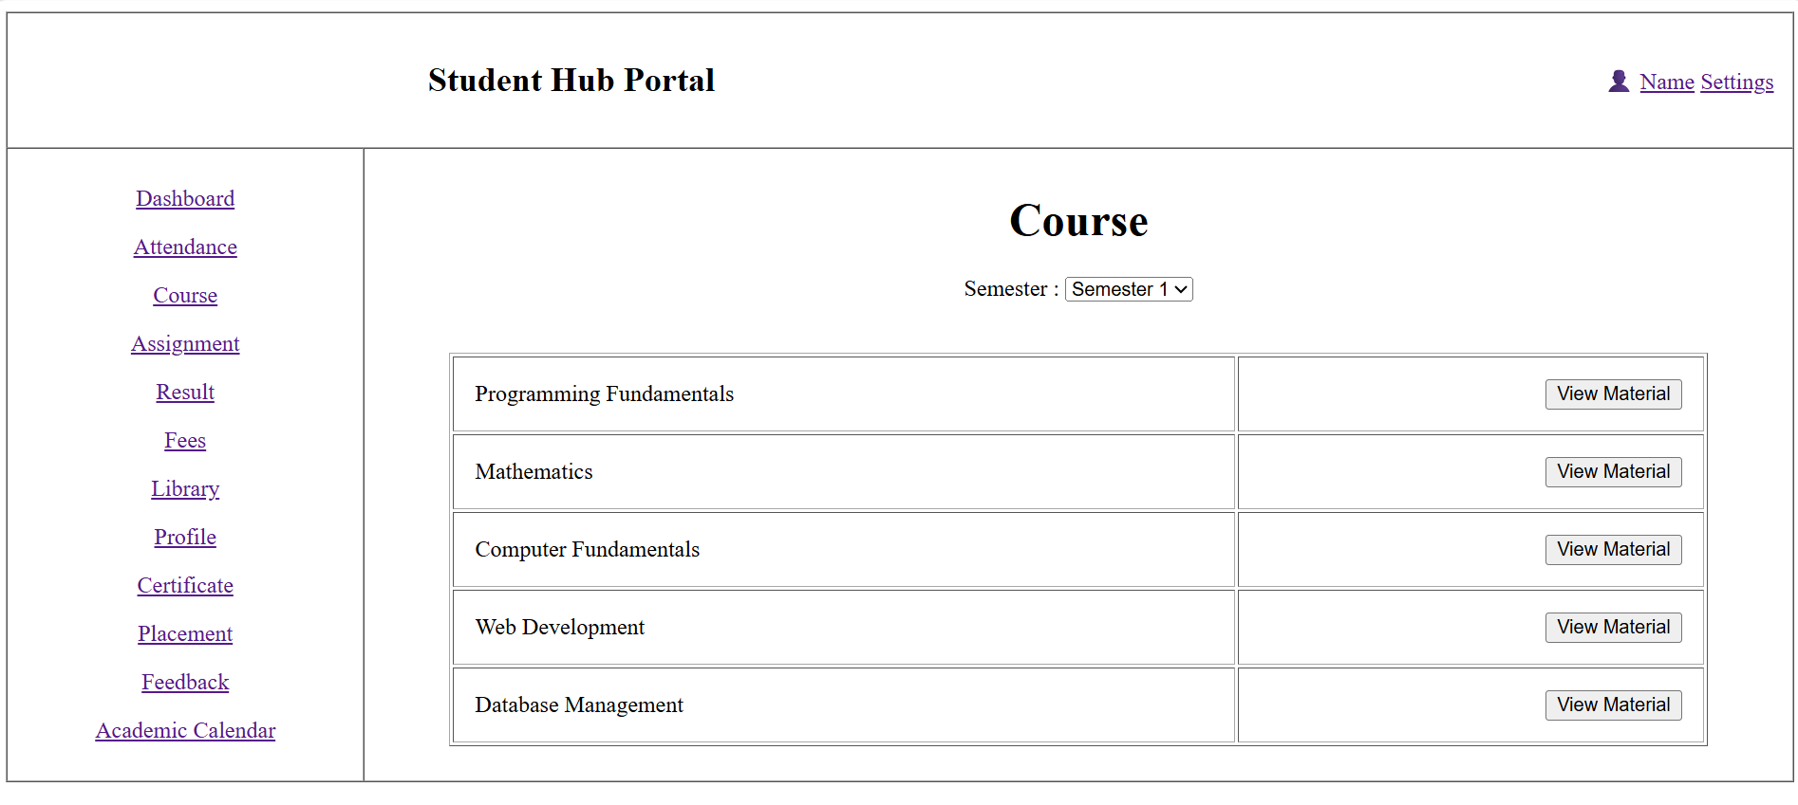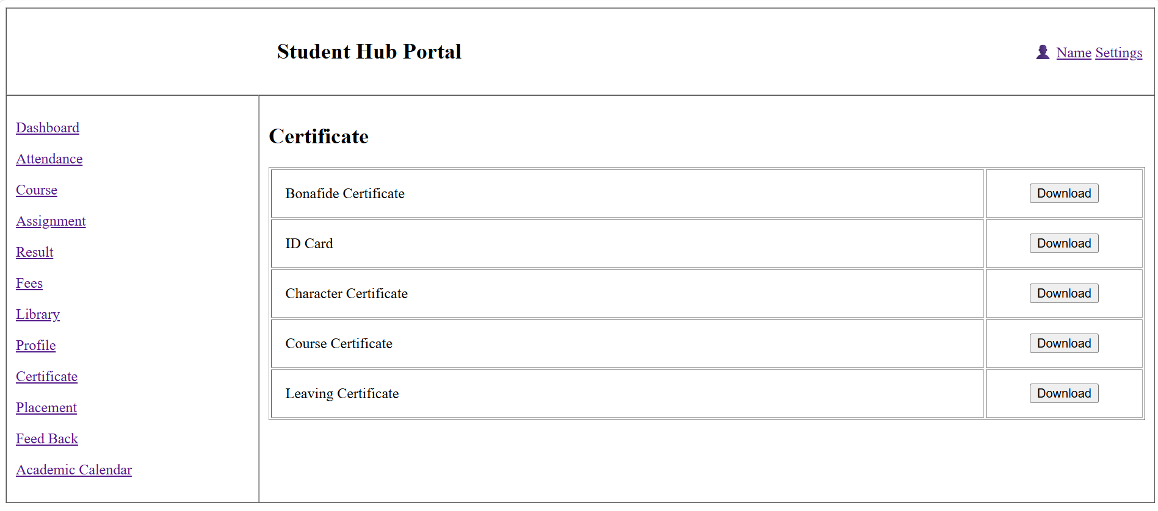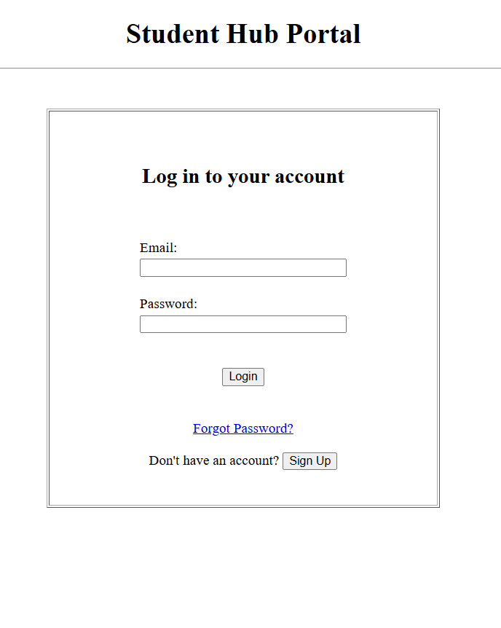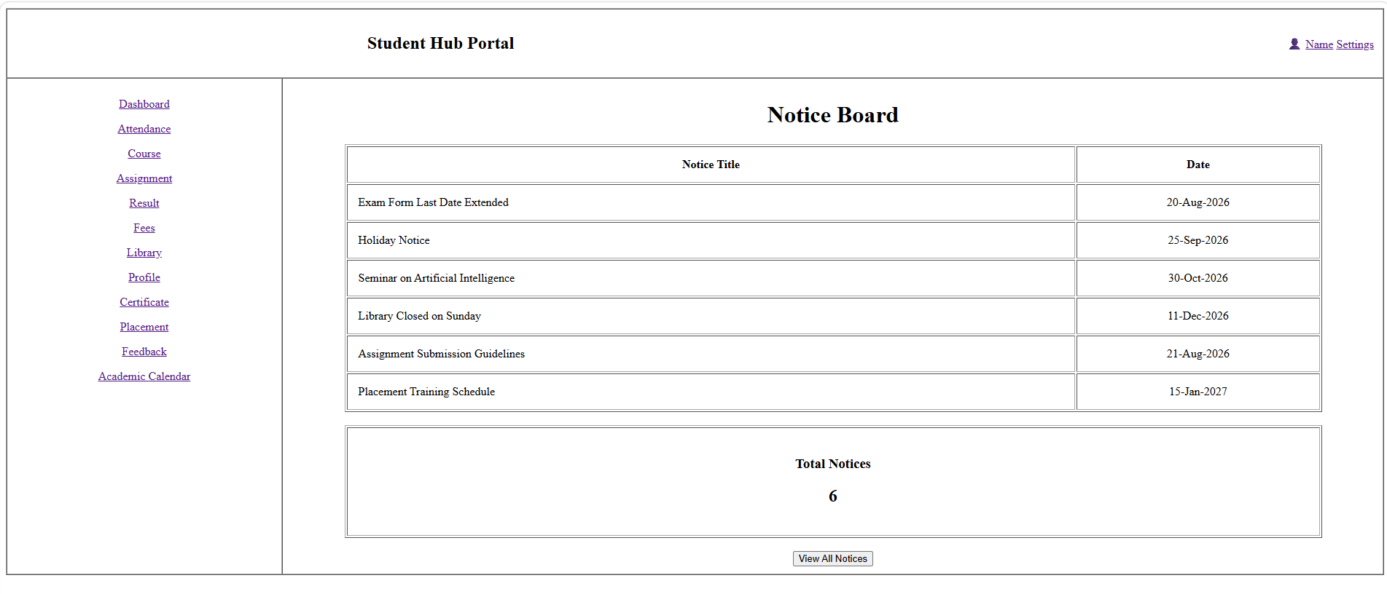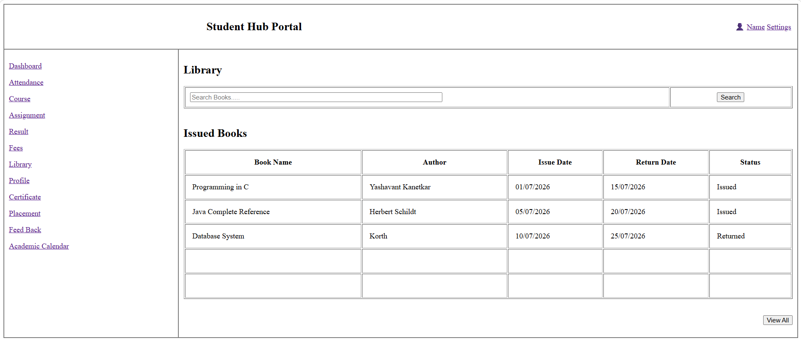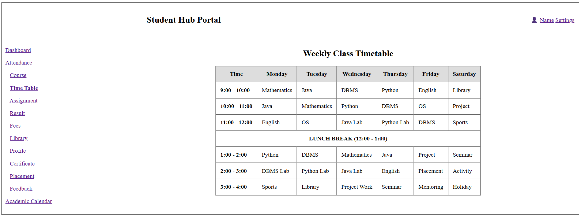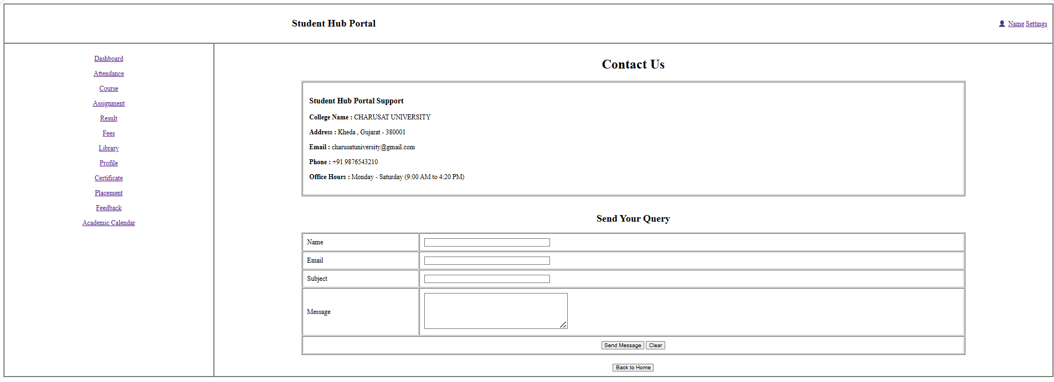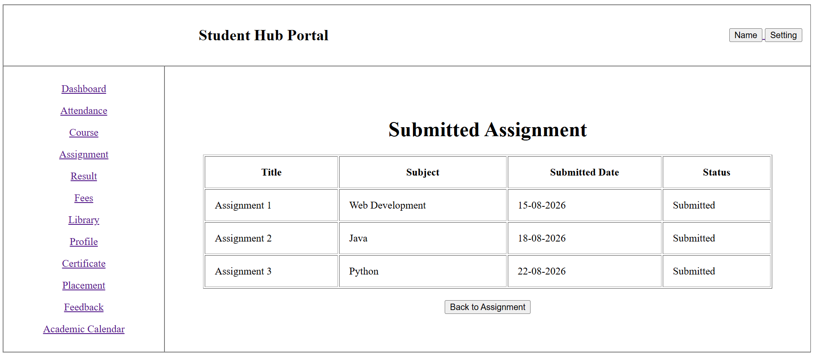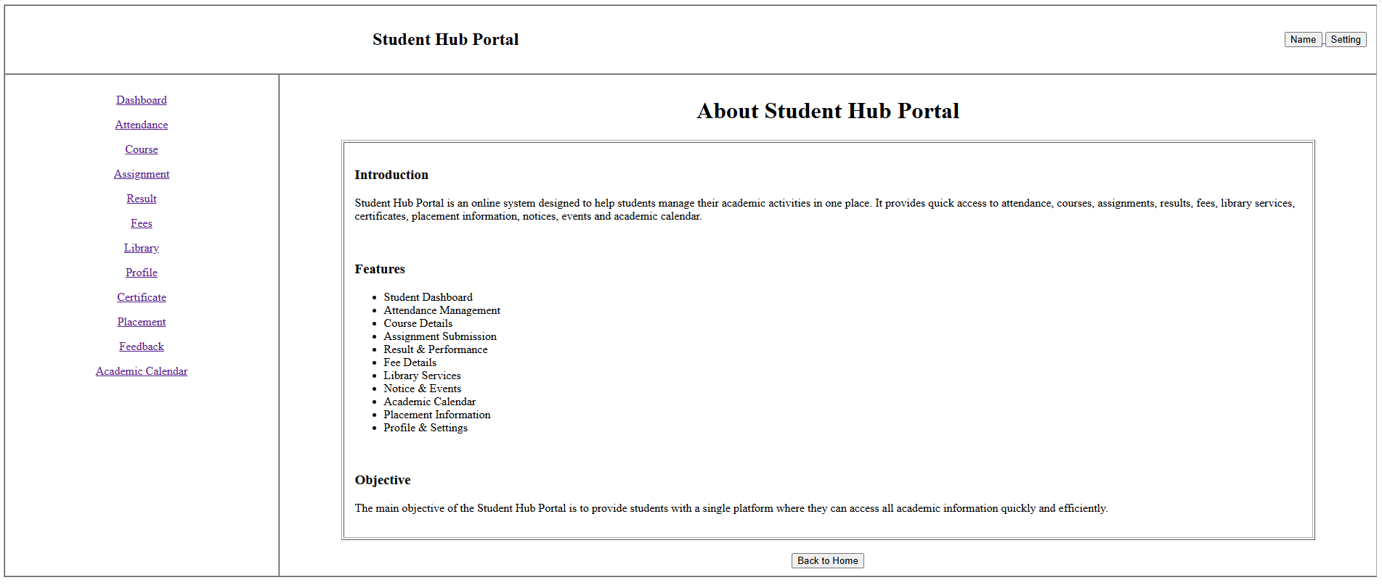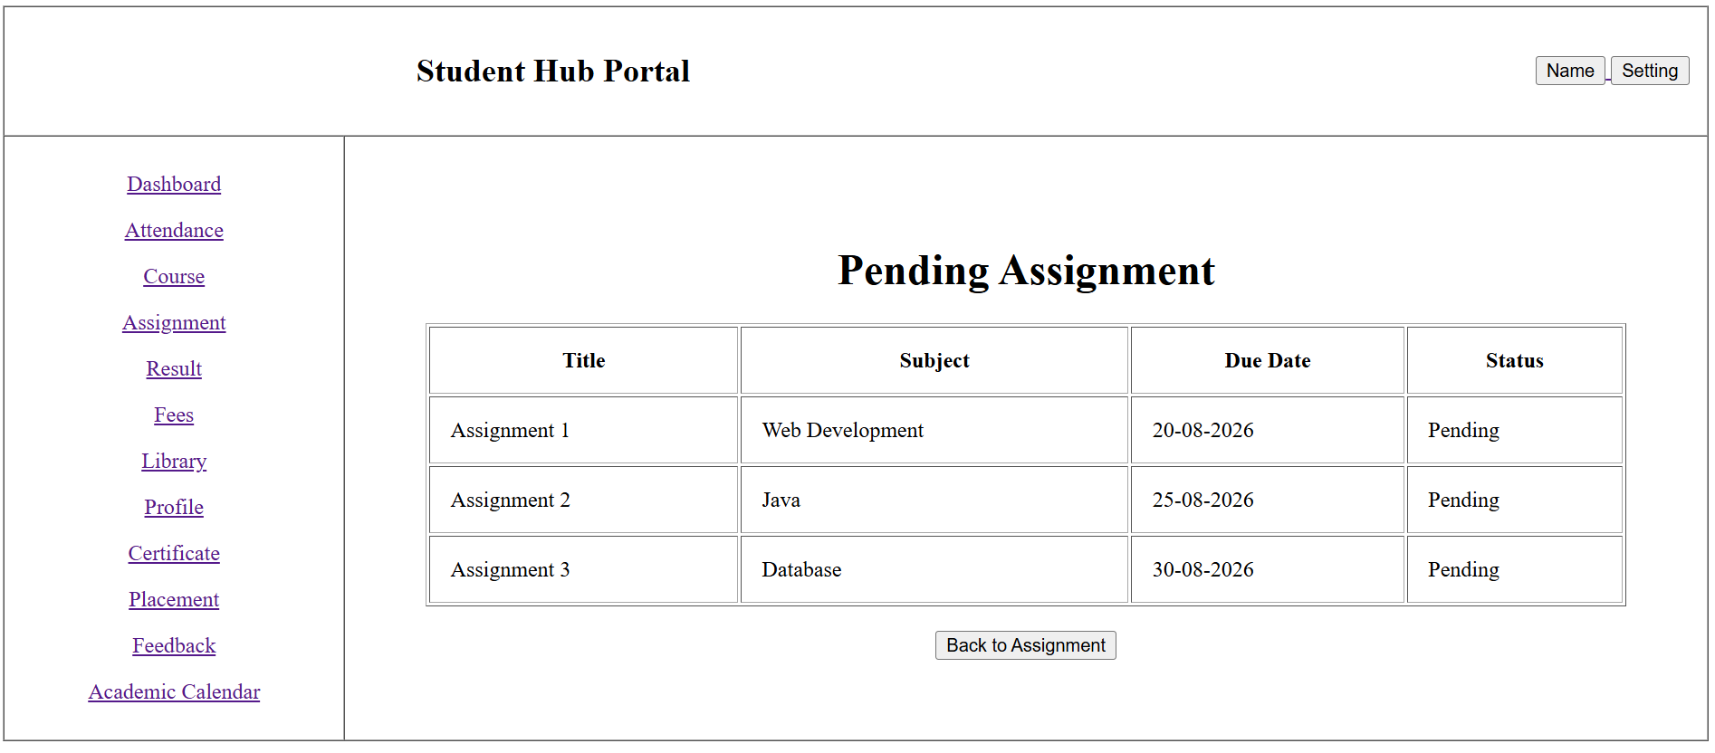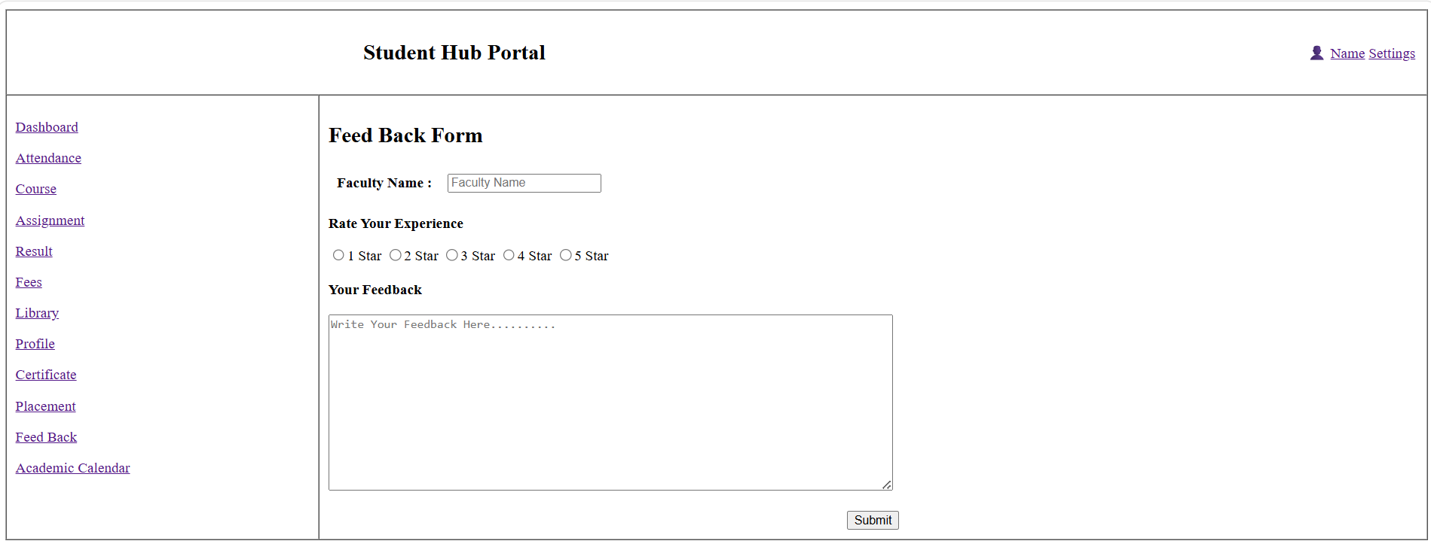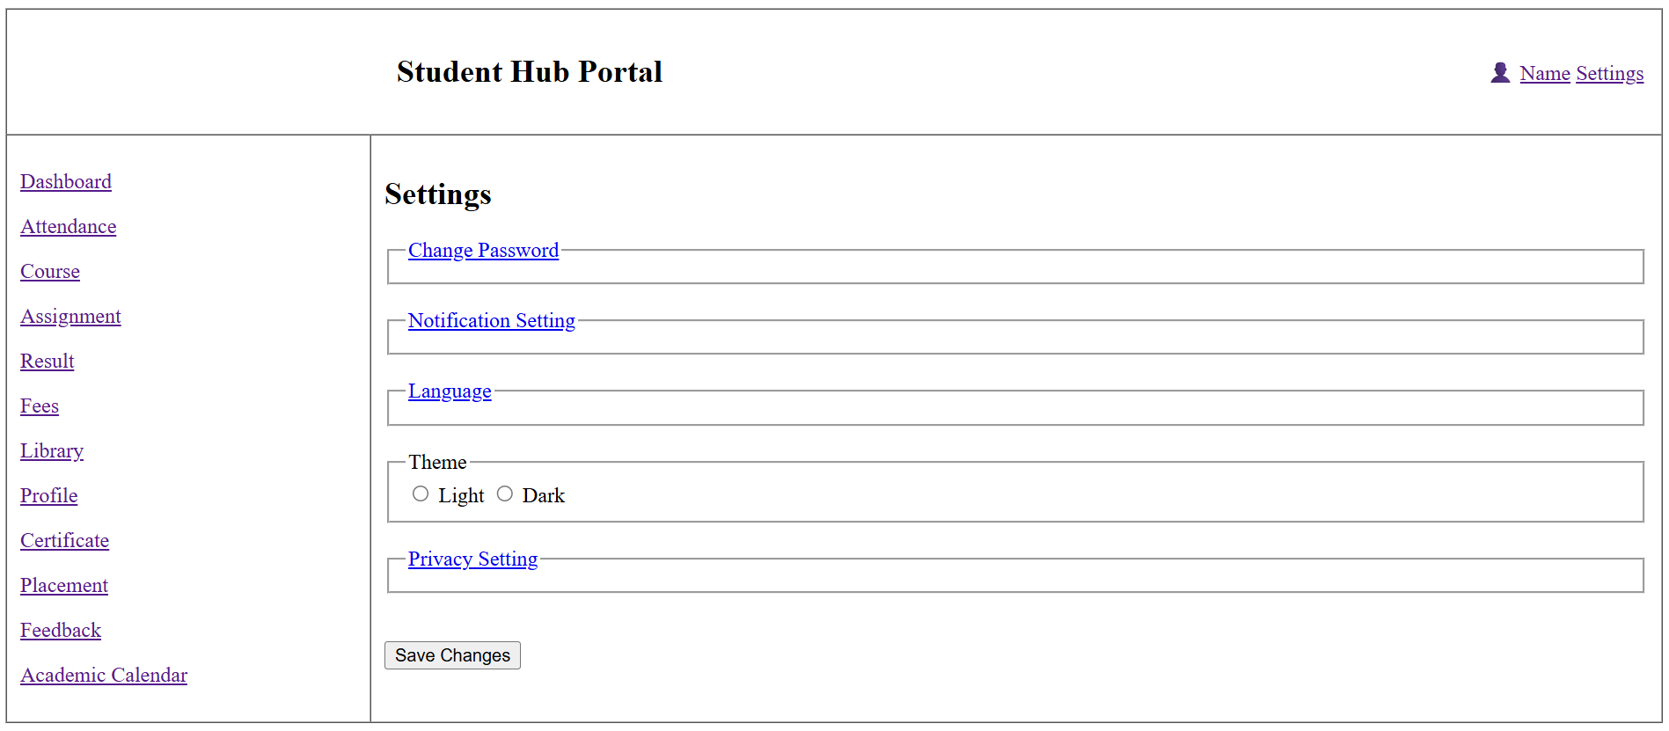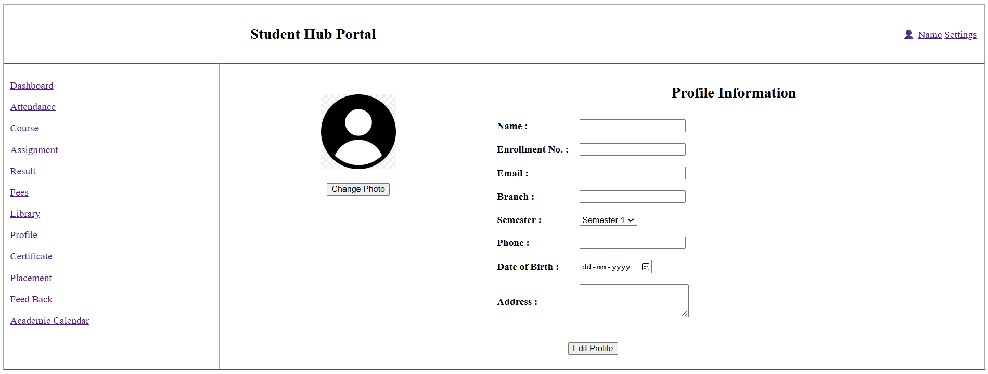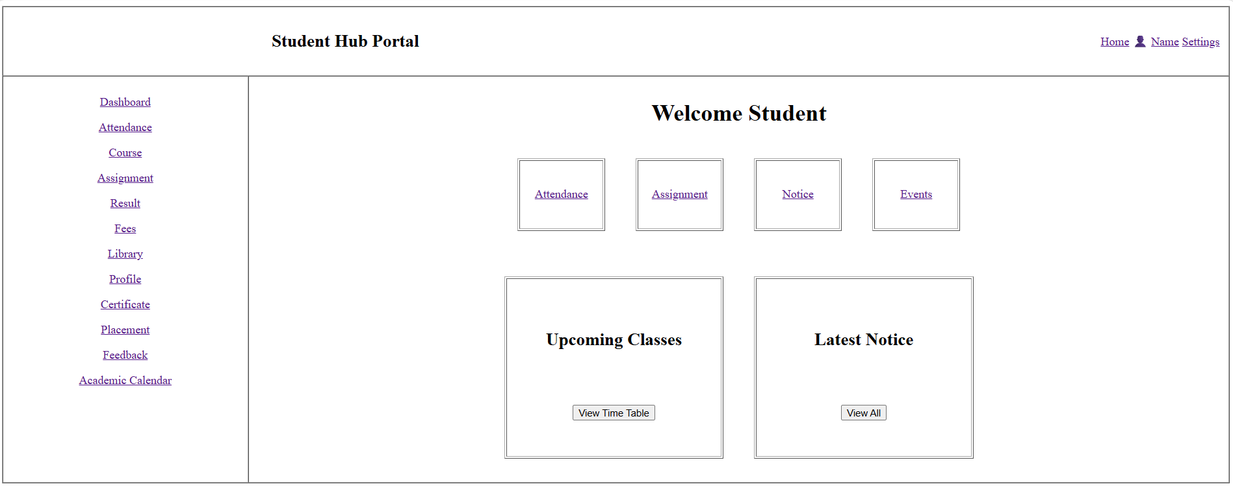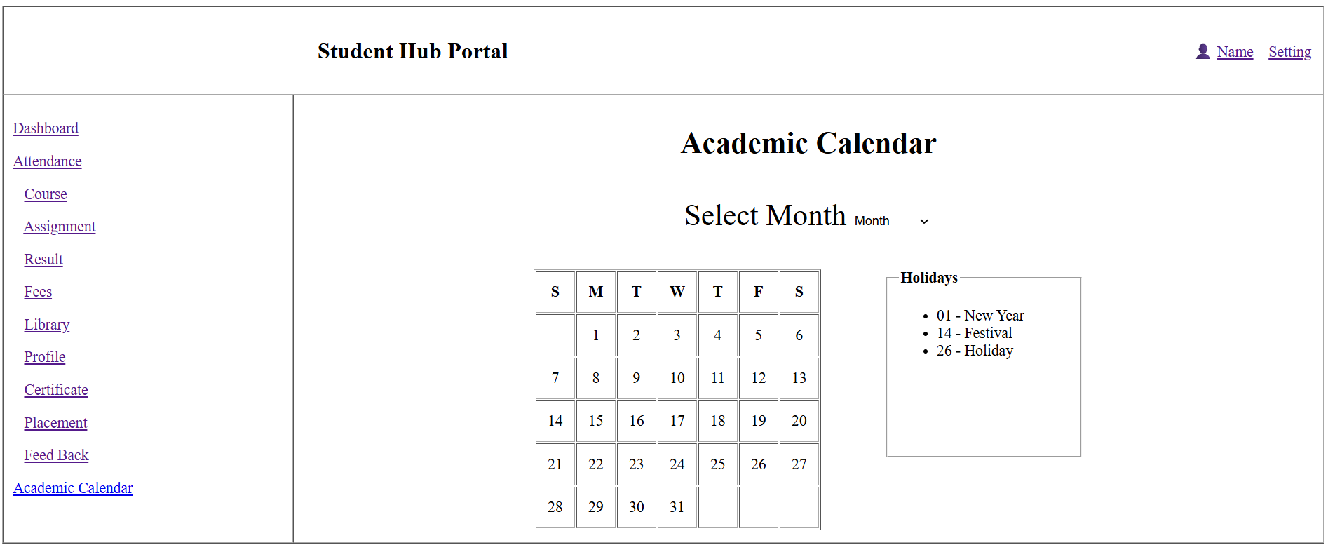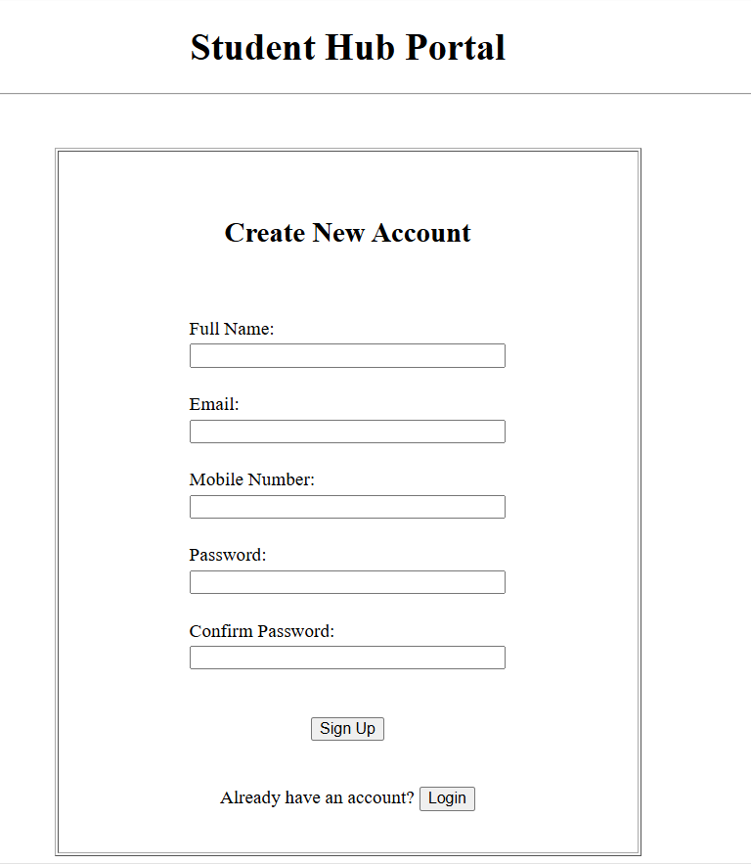

GitHub Repository Link:

https://github.com/Andarpadhruvi1125/Student-Hub-portal.git

Challenges Faced:
While developing the Student Hub semantic HTML5 pages, I faced some challenges in maintaining a proper structure using semantic tags like header, nav, main, section, article, and footer. Linking multiple pages correctly and keeping the same navigation structure across all pages was a little difficult. I also learned that adding proper labels, headings, and image alt text is important for making webpages accessible.

Learning Outcomes:
From this practical, I learned how to create structured HTML5 pages using semantic elements and accessibility-friendly practices. I understood how to link multiple pages, design consistent navigation menus, use proper content hierarchy, and create a clean foundation for a static website. This practical improved my knowledge of HTML5 structure and accessible web design.

Faculty Remarks: (Keep this blank for faculty)

